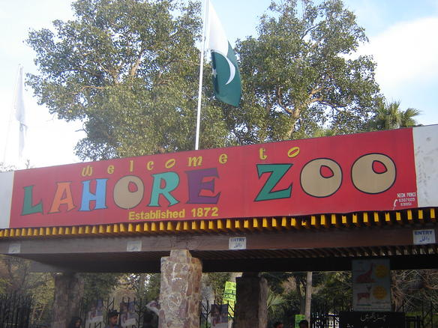

About Lahore Zoo Park

What is Lahore Park Zoo? and where is located established? The Lahore Zoo is one of the oldest and most prominent zoos in Lahore, Pakistan, as well as one of the oldest zoos in the world. It is a major attraction for residents and tourists, providing a space for recreation, education, and wildlife conservation The zoo is located on Mall Road, Lahore, near other historical landmarks such as Bagh-e-Jinnah and Lahore Museum 1872, making it one of the oldest zoos in South Asia. Initially started as an aviary,

it gradually expanded to house a variety of animals.

Opening & Closed Timings

Opening Time: 9:00 AM To Closed 6:00 PM

Typically, the last admission is allowed around 5:30 PM to give visitors enough time to explore before the zoo closes.

The Lahore Zoo does not have specific "ladies-only" timings as it is open to all visitors during its regular hours. Families, women, and individuals can visit the zoo at any time during the standard operating hours.

The Lahore Zoo is open to families throughout its regular operating hours. There are no specific designated "family-only" timings; families can visit at any time during the zoo's normal hours of operation.

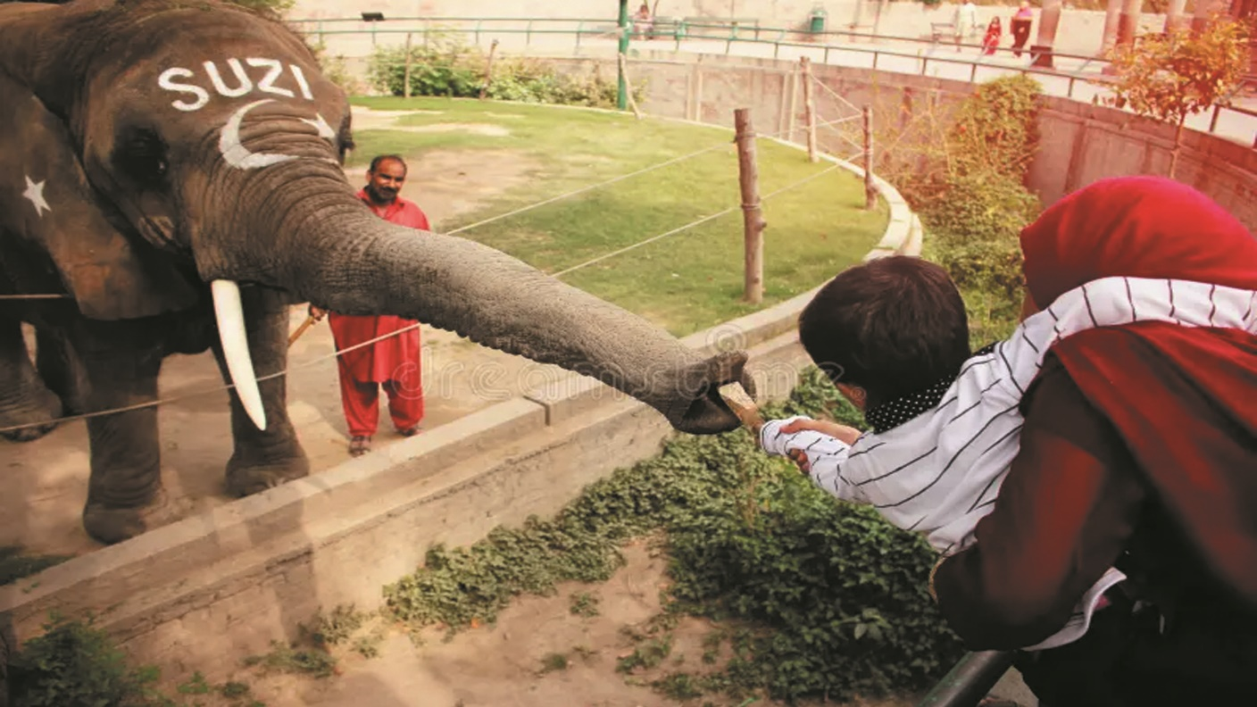

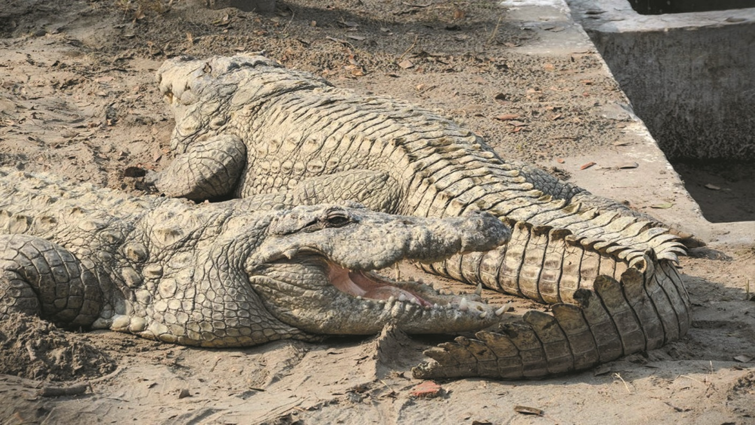

Animals List

The Lahore Zoo is home to around 1,200 animals from approximately 120 species, including mammals, birds, reptiles, and amphibians. It is one of the largest and oldest zoos in Pakistan, offering a diverse collection of wildlife for visitors to explore. Notable exhibits include:

Lions

Zebra

Deer

Hippopotamuses

Crocodiles

Snakes

Gorillas

Elephant

Monkeys

Address & Contact

Address: Mall Road, Lahore, Punjab, Pakistan

The zoo is located in the heart of Lahore, near Bagh-e-Jinnah and other historical landmarks.

For questions related to visiting, opening times, directions, accessibility, or other general information, you can visit their [Support Centre]( https://wildlife.punjab.gov.pk).

Email: For specific enquiries you can fill out the contact form available on their (info@wildlife.punjab.gov.pk).

Phone: For urgent enquiries, you can call their Supporter Contact team at +92 42 99202625.

For the most accurate and up-to-date information, it's recommended to visit the [official Lahore Zoo website]( https://wildlife.punjab.gov.pk).